Final draft

ECMAScript® Test Suite
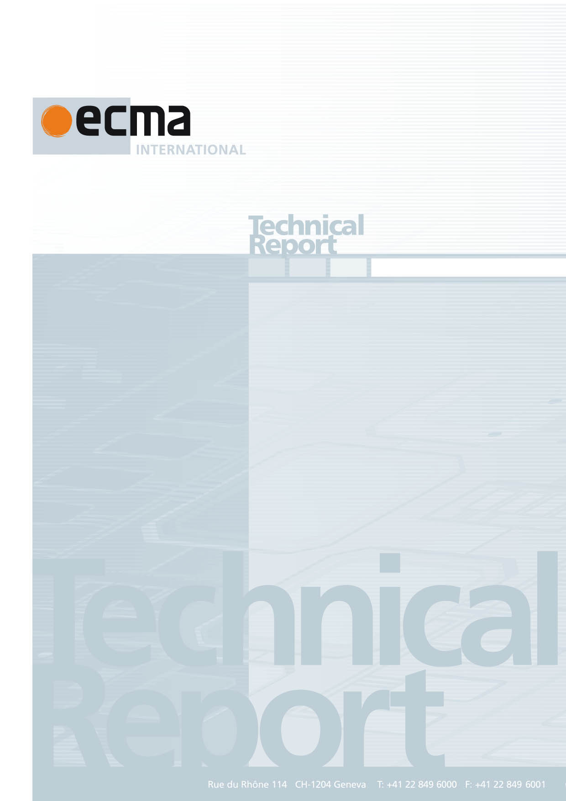
Ecma/TC39/2016/NN

ECMA TR/104
2nd Edition / September 2016

Contents Page
1 Scope 1
2 References 1
3 Abbreviations 1
4 Status 1
5 Contributions 1
6 Relation to ECMA-414 2
Introduction
Test262 is a project of Ecma International's Technical Committee 39 that has a goal to make a test suite widely available that can be used by ECMAScript implementers to improve their adherence to the Ecma-414 (which normatively includes ECMA-262 and ECMA-402) specification. The test suite consists of individual tests that have been contributed by Ecma TC39 members. The test262 test suite is publicly available at https://github.com/tc39/test262.

This Ecma Technical Report was developed by Technical Committee 39 and was adopted by the General Assembly of December 2016.

"COPYRIGHT NOTICE
© 2016 Ecma International
This document may be copied, published and distributed to others, and certain derivative works of it may be prepared, copied, published, and distributed, in whole or in part, provided that the above copyright notice and this Copyright License and Disclaimer are included on all such copies and derivative works. The only derivative works that are permissible under this Copyright License and Disclaimer are:
(i) works which incorporate all or portion of this document for the purpose of providing commentary or explanation (such as an annotated version of the document),
(ii) works which incorporate all or portion of this document for the purpose of incorporating features that provide accessibility,
(iii) translations of this document into languages other than English and into different formats and
(iv) works by making use of this specification in standard conformant products by implementing (e.g. by copy and paste wholly or partly) the functionality therein.
However, the content of this document itself may not be modified in any way, including by removing the copyright notice or references to Ecma International, except as required to translate it into languages other than English or into a different format.
The official version of an Ecma International document is the English language version on the Ecma International website. In the event of discrepancies between a translated version and the official version, the official version shall govern.
The limited permissions granted above are perpetual and will not be revoked by Ecma International or its successors or assigns.
This document and the information contained herein is provided on an "AS IS" basis and ECMA INTERNATIONAL DISCLAIMS ALL WARRANTIES, EXPRESS OR IMPLIED, INCLUDING BUT NOT LIMITED TO ANY WARRANTY THAT THE USE OF THE INFORMATION HEREIN WILL NOT INFRINGE ANY OWNERSHIP RIGHTS OR ANY IMPLIED WARRANTIES OF MERCHANTABILITY OR FITNESS FOR A PARTICULAR PURPOSE."

ECMAScript® Test Suite

Scope
This Ecma Technical Report describes a test suite and harness developed by TC39 members and other contributors to validate how well an implementation of the ECMAScript adheres to the ECMA-414 suite of standards. It is assumed that readers are familiar with general software testing methodologies and the ECMA-262.

References
The following documents, in whole or in part, are normatively referenced in this document and are indispensable for its application. For dated references, only the edition cited applies. For undated references, the latest edition of the referenced document (including any amendments) applies.
ECMA-262, ECMAScript Language Specification
ECMA-402, ECMAScript® 2016 Internationalization API Specification
ECMA-404, The JSON Data Interchange Format
ECMA-414, ECMAScript® Specification Suite

Abbreviations
TC39 Technical Committee 39
test262 The software test suite defined by this report

Status
Development of test262 is an on-going process. As of September 2016, test262 consisted of over 23700 individual test files covering the majority of the pseudo-code algorithms defined in the ECMA-414 Standards Suite. Each of these files contains one or more distinct test cases. This marks the most comprehensive ECMAScript test suite to date. While test coverage is broad, TC39 does not consider coverage to be complete and as with any software project there exists the possibility of omissions and errors. As TC39 members correct issues or contribute further tests the test suite will be updated at https://github.com/tc39/test262 which also contains the active development version of the source code. The most recent version of the test suite is available at https://github.com/tc39/test262/tree/master, which references the git master branch of the source code repository.

Contributions
Test262 was initially composed of contributions from Ecma members Google and Microsoft. Google contributed tests from its Sputnik project, a test suite for ECMA-262 Edition 3. Microsoft contributed tests from its Internet Explorer Testing Center, a test suite for the Standard ECMA-262 Edition 5.1 features and changes from Edition 3. Development of test262 began in earnest in summer 2010. Since that time, thousands of additional tests have been contributed by TC39 member organizations and members of the world-wide ECMAScript community.
A guide for contributions can be found at https://github.com/tc39/test262#contributing-to-test262 which requests community users to sign the CLA and documents test authoring guidelines.
All tests on test262 are declared as text files located within its project's test directory. Test262 does not offer any specific runner for the tests but lists current available runners maintained by community volunteers at https://github.com/tc39/test262#running-test262. A documentation for tests interpretation is available at https://github.com/tc39/test262/blob/master/INTERPRETING.md.

Relation to ECMA-414
The Standard ECMA-414 along with the standards that it normatively references provides the normative definition of the ECMAScript programming language. Test262 is a non-normative test suite for implementations of Standard ECMA-414. Any differences between the requirements of ECMA-414 and those tested by test262 must be resolved in favour of the ECMA-414 specification.

The name “Test262” is an historic artifact reflecting the fact that originally the test suite only contained tests relating to the ECMA-262 standard. With the introduction of ECMA-414 it also includes tests to other standards like ECMA-402.

